LOCAL FARMER PRE-ORDER SYSTEM
@CREATIVITY THINK (9483175986/7019689991)

ABSTRACT:
The Local Farmer Pre-Order System is a dynamic web-based platform designed to streamline weekly crop ordering between farmers/co-operative groups and local consumers. The system enables users to browse a catalog of available crops, place pre-orders, select pickup slots, and manage payments using an internal wallet flagged for “cash on pickup.” On the farmer/co-op side, the system offers tools to manage crop listings, set availability limits, adjust or confirm orders, track order fulfillment, and analyze demand patterns through an interactive dashboard. Built using Django REST Framework for the backend and React with Redux for the frontend, this project provides a reliable, efficient, and scalable solution for supporting local agricultural commerce..

INTRODUCTION OF THE PROJECT:
With increasing demand for fresh and locally sourced produce, farmers and residential communities seek digital platforms that simplify weekly crop distribution. Traditional offline methods—WhatsApp groups, paper lists, and manual tracking—are inefficient and error-prone. The Local Farmer Pre-Order System addresses these challenges by creating a structured workflow for listing crops, accepting pre-orders, managing pickups, and maintaining transparent order statuses. By integrating internal wallet logic and slot-based pickup scheduling, the platform enhances both farmer efficiency and user convenience..

PROJECT OBJECTIVES:

• Provide an online catalog for weekly crop availability
• Enable users to place crop pre-orders with quantities and pickup slots
• Maintain an internal wallet system with “cash on pickup” option
• Offer order summary, history, and pickup confirmation features
• Allow farmers/co-op admins to manage crop prices, stock, and slot limits
• Enable order confirmation, adjustment, cancellation, and fulfillment
• Provide a dashboard with analytics on demand, stock usage, and waste
• Reduce miscommunication and manual workload in weekly distribution

PROBLEM OF THE STATEMENT:
Farmers and cooperative groups commonly face issues like overbooking, miscalculations, and communication delays when handling weekly pre-orders. Customers often have limited visibility into available crops or pickup slots. Without a structured system, tracking demand, order fulfillment, and stock wastage becomes difficult. This project aims to solve these challenges by offering a centralized digital solution that accurately manages pre-orders, inventory levels, wallet balance tracking, and pickup logistics..

MOTIVATION OF THE PROJECT:
• To support local farmers and community agriculture initiatives
• To reduce food waste by enabling demand-based planning
• To simplify pre-order management for weekly markets and societies
• To provide customers with an organized and convenient ordering system
• To eliminate manual tracking and reduce logistical confusion
• To promote digital adoption among small agricultural groups
• To provide accurate analytics for better crop planning

BLOCK DAIGRAM OF PROJECT:

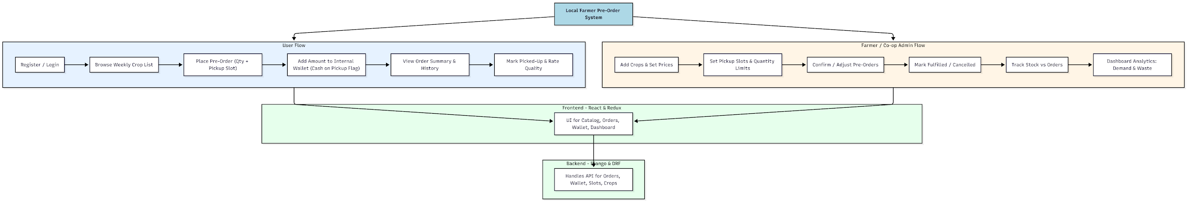

WORKING OF THE PROJECT:
Users begin by registering on the platform and browsing the weekly crop catalog published by farmers or co-op administrators. They select the quantity and preferred pickup slot and place the pre-order. The internal wallet functions as a balance tracker, where users mark amounts as “cash on pickup,” ensuring farmers know expected payments. Users can review order history, check pickup status, and rate the quality of crops received.
Farmers/co-op administrators manage backend operations by adding crops, setting pricing, and establishing pickup slots and quantity limits. They can confirm customer orders, adjust quantities, or cancel them based on availability. During pickup, admins mark orders as fulfilled or cancelled and review dashboard analytics to understand demand patterns, popular crops, and stock waste. This enables better planning for future weeks..

SOFTWARE REQUIREMENT:
- Backend:
  - Python 3.x
  - Django
  - Django REST Framework
  - SQLite/PostgreSQL
- Frontend:
  - Node.js and npm
  - React.js
  - Axios
- Development Tools:
  - Visual Studio Code
  - Postman (for testing APIs)
  - Git/GitHub (for version control)
- Server/Deployment (Optional):
  - Gunicorn, Nginx, or Heroku/AWS for hosting

ADVANTAGES OF THE PROJECT:

• Eliminates manual crop booking and tracking
• Reduces food waste through accurate pre-order analytics
• Ensures transparent communication between farmers and users
• Slot-based pickup reduces crowding and delays
• Internal wallet simplifies payment tracking
• Dashboard helps forecast demand and improve planning
• Works for weekly markets, societies, and cooperative setups
• Highly scalable for multiple farmers and communities

APPLICATIONS OF THE PROJECT:
• Housing societies purchasing weekly fresh produce
• Local farmers selling directly to communities
• Cooperative agricultural groups
• Weekly farmer markets
• Small organic produce networks
• Community-supported agriculture (CSA) systems

REFERENCES:

- Django REST Framework Documentation — Django Software Foundation. Django Documentation. Available: https://docs.djangoproject.com/
- Django REST Framework. DRF Documentation. Available: https://www.django-rest-framework.org/
- React. React Official Documentation. Available: https://reactjs.org/docs/getting-started.html
- Redux. Redux Documentation. Available: https://redux.js.org/introduction/getting-started
- PostgreSQL Global Development Group. PostgreSQL Documentation. Available: https://www.postgresql.org/docs/
- MySQL. MySQL Reference Manual. Available: https://dev.mysql.com/doc/
- Git. Git Documentation. Available: https://git-scm.com/doc
- Node.js. Node.js Documentation. Available: https://nodejs.org/en/docs/
- Axios. Axios Documentation. Available: https://axios-http.com/docs/intro
- Socket.io Documentation – https://socket.io/docs/

